**THE HIDING BOAT -TITANIC**

**CONTENTS**

* **Objects**
  + **Functions**
  + **Algorithms**
* **Update Redisplay**

**FILES LIST:**

**MAIN.CPP**

**LIBRARY_OBJECTS.CPP**

**Objects**

**The objects used in this project:**

|  |  |  |  |
| --- | --- | --- | --- |
| OBJECT NAME | DESCRIPTION(IMAGE) | PARAMETERS | FUNCION USES FROM GLUT(OPENGL) |
| NIGHT SKY |  | **Night(int)**  --> if the value is 0 the color changes into morning theme. For 1 the color stays the same. | glColor3f(),  glBegin(GL_TRIANGLE),  glBegin(GL_QUADS),  glVertex2i() |
| MOON |  | **Moon**  -> for 0 mood hides for 35 moon reveals | Custom library:  --- use circle function that creates a circle using small triangle and filling it with white color by passing rgb parameter.  OPENGL LIBRARY:  ---used glBegin(GL_TRIANGLE)  TO CREATE SMALL TRIANGLES FROM THE CENTER AS ONE COMMON POINT. |
| WINDMILL |  | **Windmill:**  Passed theta value to change the position of the triangles. Passed coordinate value to change the position of the windmill object.  Passed (x+translation) to change the other 2 windmill coordinate in xy plane. |  |
| SEA |  | **NO PAREMETER PASSED FOR THIS OBJECT.** | **JUST A SIMPLE GL_QUADS WITH 4 CORDINATES** |
| SMALLBOAT |  | **PASSED INCREMENTTED VALUE TO ALL THE X CORDINATE TO MOVE THE BOAT FROM LEFT TO RIGHT. SAME AS THE BIG BOAT** | **USED GL_QUADS AND GL_TRIANGLES FOR CREATING THE BOAT AND glColof3f(); for the parotic color.** |
| BIGBOAT (TITANIC) |  | **As same as the small boat passed x incremented value in the boat to move it in the x direction left->right of right->left** | Custom library:  --- use circle function that creates a circle using small triangle and filling it with white color by passing rgb parameter.  **Opengl library:**  **Used to create glbegin->GL_QUADS TO CREATE THE SQUEARE CHIMNIS**  **AND OTHER SQUARE SHAPES. NOT TRIANGLE LIBRARY HABE BEEN USED HERE.** |
|  |  |  |  |

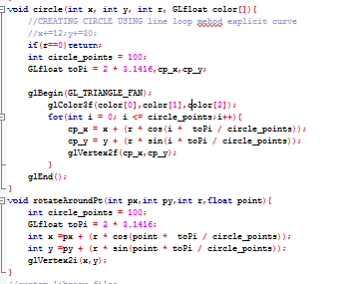

**ALGORITHMS:**

**The algorithms use in the functions:**

**Circle, Rotatearoundpt functions are used to draw variable shaped circles using circle drawing algorithms.**

**The mechanics for movement in the x direction for boats(all):**

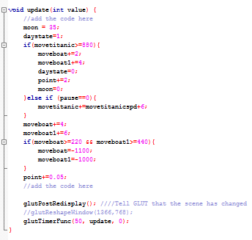

**The full scene from a single moment:**

